**Parish Council Meeting Minutes**

**Date**: Tues. Jan 21, 2025, **Time:**  6:30 PM. **Place:** Notre Dame Church Hall

**Attendees: 12**

* Sal Merenda
* Bobbie Sicignano
* Carol Banack
* Diana Cathcart
* Mario Pereira
* Ray Arrigoni
* Tom Capega
* Nadine Ernst
* Karen Whalen
* Gail Mullaney
* Tim Murphy
* Pat Sicignano

1. Call to Order: Sal Merenda called the meeting to order at 6:40 PM
2. Opening Prayer: Sal offered prayer
3. Minutes: No corrections, additions or omissions reported
4. Reports:

* FINANCE COMMITTEE:

No official report (Chairmen are away)

Sal said at last Finance meeting we seem to be doing well.

*Improvements/Projects we anticipate* per Ray and Tom:

1. St. Colman: Roof (upper-level needs replacement)
2. St. Colman Boiler: Tom reported after repairs, it is refurbished and currently working well
3. St. Colman: Interior Painting estimated about $30,000
4. St. Colman: Bricks need to be sealed as normal maintenance for bricks

* **Trustees Report:**

Cheryl wrote regarding Bankruptcy- “there have been no new requests for legal fees at this point”

* **Pancake Breakfast:**

Scheduled for 1st Sunday of each month from October to May (not held July-September).

Not held in December of 2024 because Christmas Fair and Bake Sale was that weekend. January was cancelled due to “uninvited visitors“  having come into the kitchen and made themselves at home. Tom said an exterminator came and he believed with the traps set, we should be okay. Debbie has contacted a service to do a deep cleaning of the kitchen. Silvana has replaced the food ingredients that had to be discarded.

1. **Fund Raisers:**

* **Tag Sales:**

Carol reported they will resume in May (5/3/25) and run through October on the 1st Saturday of each month. Garage will reopen in April for donations. Preparing and getting ready for these Tag sales is very labor intensive- sorting, cleaning, repairing, organizing and setting up displays. **Help is always welcome for whatever time anyone can offer.**

Nadine reported that their first attempt at selling item (dinnerware set) on Facebook Marketplace resulted in a successful sale!

* **Durham Fair**:

Nothing to report

1. **Ministry Reports:**

* Faith Formation:
* Christmas pageant at St. Colman’s Vigil Mass was very nice
* Dates set for: Confirmation (4/26/25)

1st Holy Communion (5/10/25 @10 AM)

* **St. John Paul School:** No Report
* **Property Management**: (see notes of anticipated projects under Finance report)
* **Ladies Guild**: Diana reported:

All boxes of Christmas Cookies were sold. (120 boxes x $10 = $1200)!

Planning *High Tea* scheduled for May 31st 2025

* **Knights of Columbus**: Ray reported
  1. Weekend of **February 8 & 9th** they will have a “**Bucket Drive**” at both Churches in honor of Carol Nelson, who recently passed, to raise donations for Amazing Grace in Middletown. This was a fund raiser event close to Carol’s heart.
  2. Annual ***St. Patrick’s Day Dinner*** will be held on Saturday, March 15th at ND. Tix are $25/ Adult & Children Free; Take-out $20.00
  3. Ray said he thought his group would once again host a meatless Pizza supper for the First Friday of Lent (3/7/25) to be held before Stations of the Cross at ND Church. Bobbie will approach Fr. Jan to be sure he is planning to hold Stations every Friday night during Lent except for Good Friday. (4/18/25). She will coordinate Soup Suppers for remaining 5 Fridays.
* **Care & Share**: No report
* **Youth Group:** No report
* **Craft Group:** Bobbie reported ***Christmas Fair*** was very successful in big part to multiple groups and people who added wonderful areas and staffed them. She recognized several individuals and groups. The Parish came together! Thank you.

Next event Group is putting on is the **Medieval Dinner and Show on 2/8/25.** Tickets are limited to 50 people and will be available after all Masses week ends of January 25 & 26 and February 1 & 2nd. Please tell family and friends about this enjoyable night out- Dinner and a Show for $30/adults. No tix available at door.

* **Flower Angels**: Carol was thanked for the beautiful display of the Altar at ND Church. The SC Altar was equally lovely. Thanks to all who worked with Carol and Cheryl for their participation in making both of our churches beautiful.
* **Outreach**: Reminder that Debbie Bellemare has sent out Sign Up Genius invitations for people to volunteer in preparing Food Items for the **Winter Sunday night supper at St. Vincent DePaul on 1/26/25.** If you are still looking to help, information has been in the bulletin or you can contact Debbie for details.
* **Eucharistic Ministers & Lectors**: Karen Whalen has taken on the task of assigning both Lectors and Eucharistic Ministers. Many people are on both lists so it makes sense to have one person do the assignments. New schedules will be out after March.
* **Parish Welcome Booklets**:

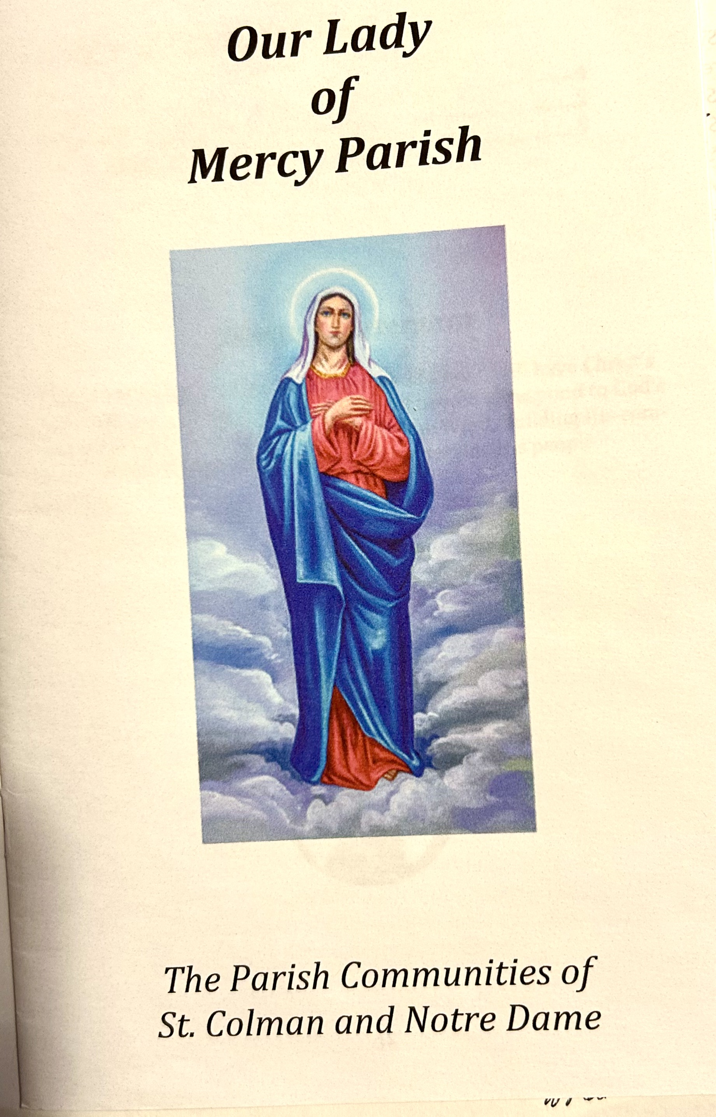

Copies of the Booklets with revisions were distributed to Council members present. **Everyone, please review booklet** - especially your own areas of responsibility. Any revisions or tweaks that you want to have changed, please send to Debbie. She is anxious to complete this project ASAP and needs your input.

If you were not present and do not have a copy of the Booklet to review, please let Debbie know as she has more copies so that you can have one.

1. **New Business:**

* Set date for **Summer Parish Picnic**. The weekend we usually choose is going to be Middlefield’s 2-day Big Celebration. We will ask Debbie to try to reserve for

June 22.

* Karen Whelan shared idea of starting group of "**JR. Lectors**.” There were many positive opinions that it would be good to include young people more in Liturgy participation. We pray at every Mass for more greater interest in consideration of vocations. We are always seeking to involve young people and families to attend Mass together. Karen was encouraged by Group to pursue idea with Fr. Jan.
* One of the goals of this Parish Council is to ensure that we remain an active, unified and vibrant parish. To that end we feel a need to explore event planning ideas for family involvement to re-energize Parish and find opportunities people would like to be part of.
* Time was spent discussing we need to let Parish know about the Parish Council- who are members; what do we do; how can they be included, etc. Suggestions such as one Parish Council Sunday be held with ALL council members be present & introduced at all Masses.
* The Choir members make our Eucharistic Celebrations so beautiful - they need to be introduced and recognized also to the Parishioners in attendance.
* Suggestions was made to perhaps create area of photos in each church identifying people by name and role they play in our Parish.
* It was strongly stated that any of this would not be successful unless everyone participates whole heartedly. In the past, some ideas start out and then fade away.
* Sal said he would schedule a meeting with Fr. Jan to bring these thoughts to him for consideration. He will report back at next meeting.

1. **Next Meeting** will be February 19th, 2025 @6:30 PM in ND Church Hall
2. **Adjournment**: Meeting was adjourned at 7:55 PM

Respectfully submitted: Bobbie Sicignano, co-chair Parish Council